**Experiment – 4**

**Student Name: Vivek Kumar UID: 21BCS8129**

**Branch: BE-CSE(LEET) Section/Group: WM-20BCS-616/A**

**Semester: 5th Date of Performance: 28/09/2022**

**Subject Name: Machine Learning Lab Subject Code: 20CSP-317**

**1. Aim/Overview of the practical:**

Implement Support Vector Machine on any data set and analyze the accuracy with Logistic regression

**2. Task to be done/ Which logistics used:**

Implement SVM on any data set using sklearn.

**3. Steps for experiment/practical/Code:**

import numpy as np

import matplotlib.pyplot as plt

from sklearn import svm

# a linear data

x=np.array([1,5,1.5,8,1,9,7,8.7,2.3,5.5,7.7,6.1,8,6])

y=np.array([2,8,1.8,8,0.6,11,10,9,4,3,8.8,7.5,12,5])

plt.scatter(x,y)

plt.show()

training_X=np.vstack((x,y)).T

training_Y=[0,1,0,1,0,1,1,1,0,0,1,1,1,0]

#DEFINE MODEL

clf=svm.SVC(kernel='linear', C=1.0)

clf.fit(training_X,training_Y)

# get the weight value for the linear equation from the trained SVM model

w=clf.coef_[0]

# get the y-offset for the liner equation

a=-w[0]/w[1]

#make the x-axis space fo the data points

xx=np.linspace(0,10)

#get the y-values to plot the decision boundary

yy=a*xx-clf.intercept_[0]/w[1]

#plot the decision boundary

plt.plot(xx,yy,'k-')

#show the plot visually

plt.scatter(training_X[:,0],training_X[:,1],c=training_Y)

plt.legend()

plt.show()

import matplotlib.pyplot as plt

import numpy as np

from sklearn import datasets

from sklearn import svm

circle_x,circle_y=datasets.make_circles(n_samples=300,noise=0.05)

plt.scatter(circle_x[:,0],circle_x[:,1],c=circle_y,marker='.')

plt.show()

#make non-linear algorithm for model

nonlinear_clf = svm.SVC(kernel='rbf',C=1.0)

#training non-linear model

nonlinear_clf.fit(circle_x,circle_y)

#plot the decision boundary for non linear SVM problem

def plot_decision_boundary(model, ax=None):

  if ax is None:

    ax = plt.gca()

  xlim = ax.get_xlim()

  ylim = ax.get_ylim()

  # create grid to evaluate model

  x=np.linspace(xlim[0],xlim[1],30)

  y=np.linspace(ylim[0],ylim[1],30)

  Y,X=np.meshgrid(y,x)

  #shape Data

  xy=np.vstack([X.ravel(),Y.ravel()]).T

  #get the decision boundary

  P=model.decision_function(xy).reshape(X.shape)

  #plot decision boundary

  ax.contour(X,Y,P,

             levels=[0],alpha=0.5,

             linestyles=['-'])

plt.scatter(circle_x[:,0],circle_x[:,1],c=circle_y,s=50)

plot_decision_boundary(nonlinear_clf)

plt.scatter(nonlinear_clf.support_vectors_[:,0], nonlinear_clf.support_vectors_[:,1],s=50, lw=1, facecolors='none')

plt.show()

**4. Result/Output/Writing Summary:**

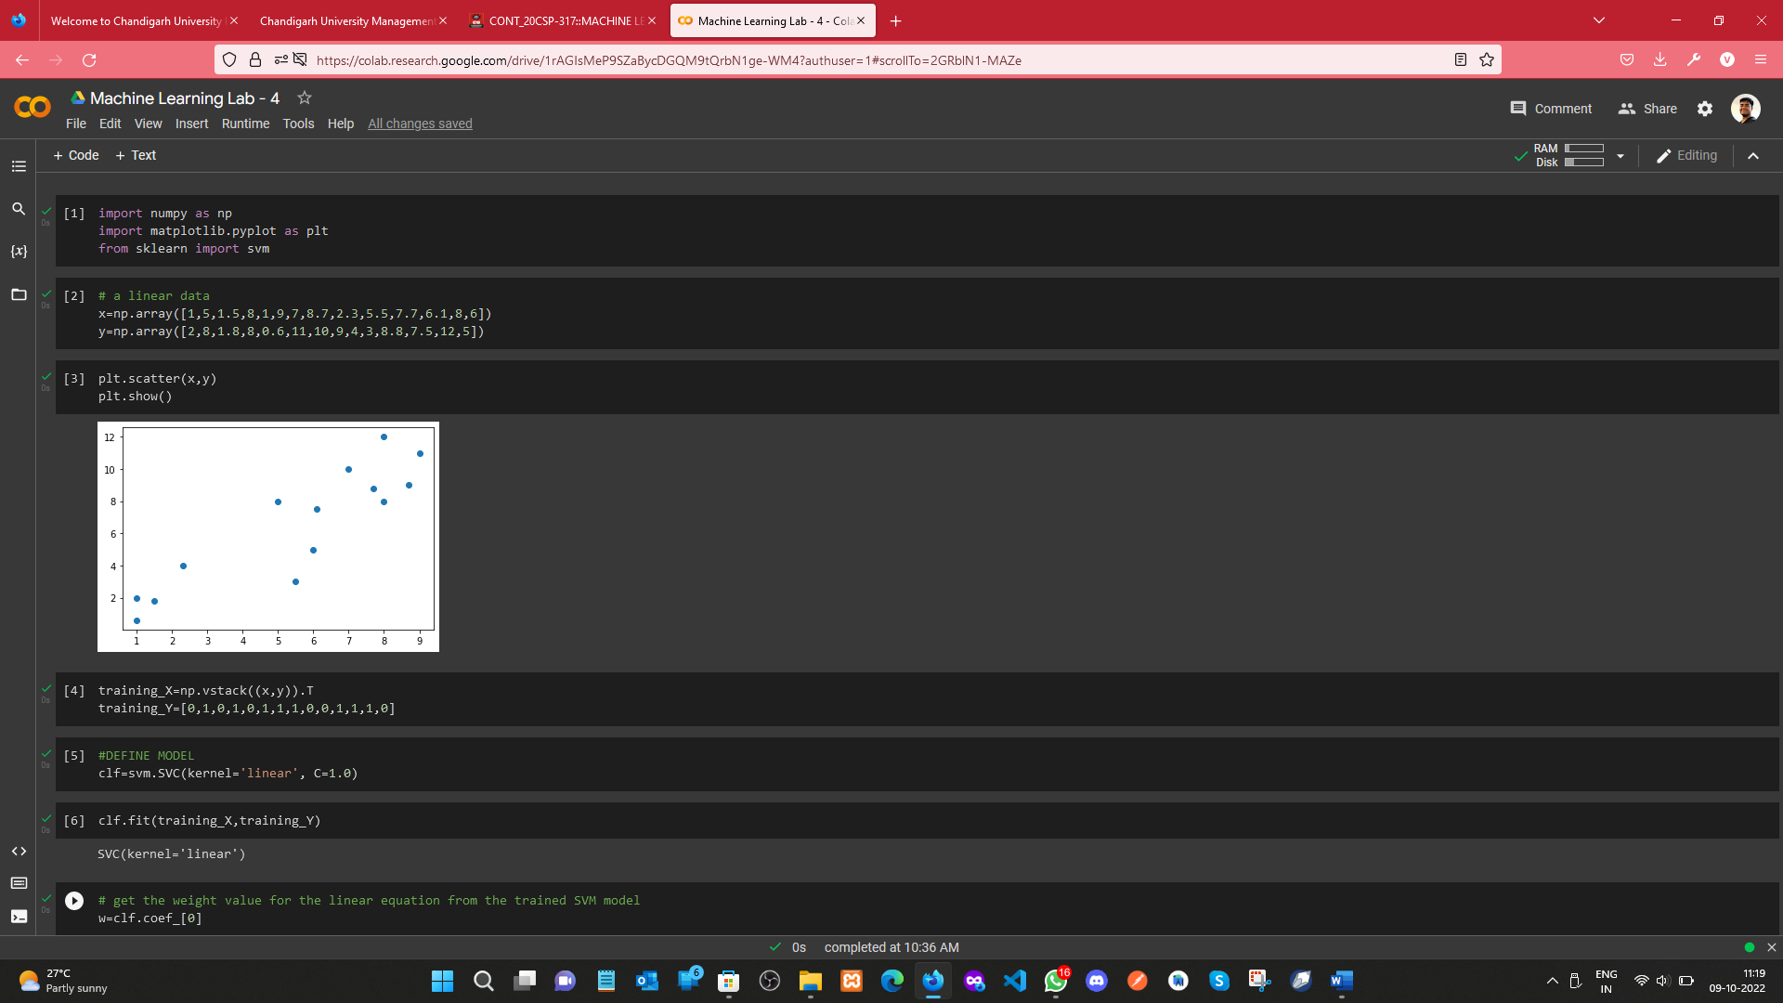

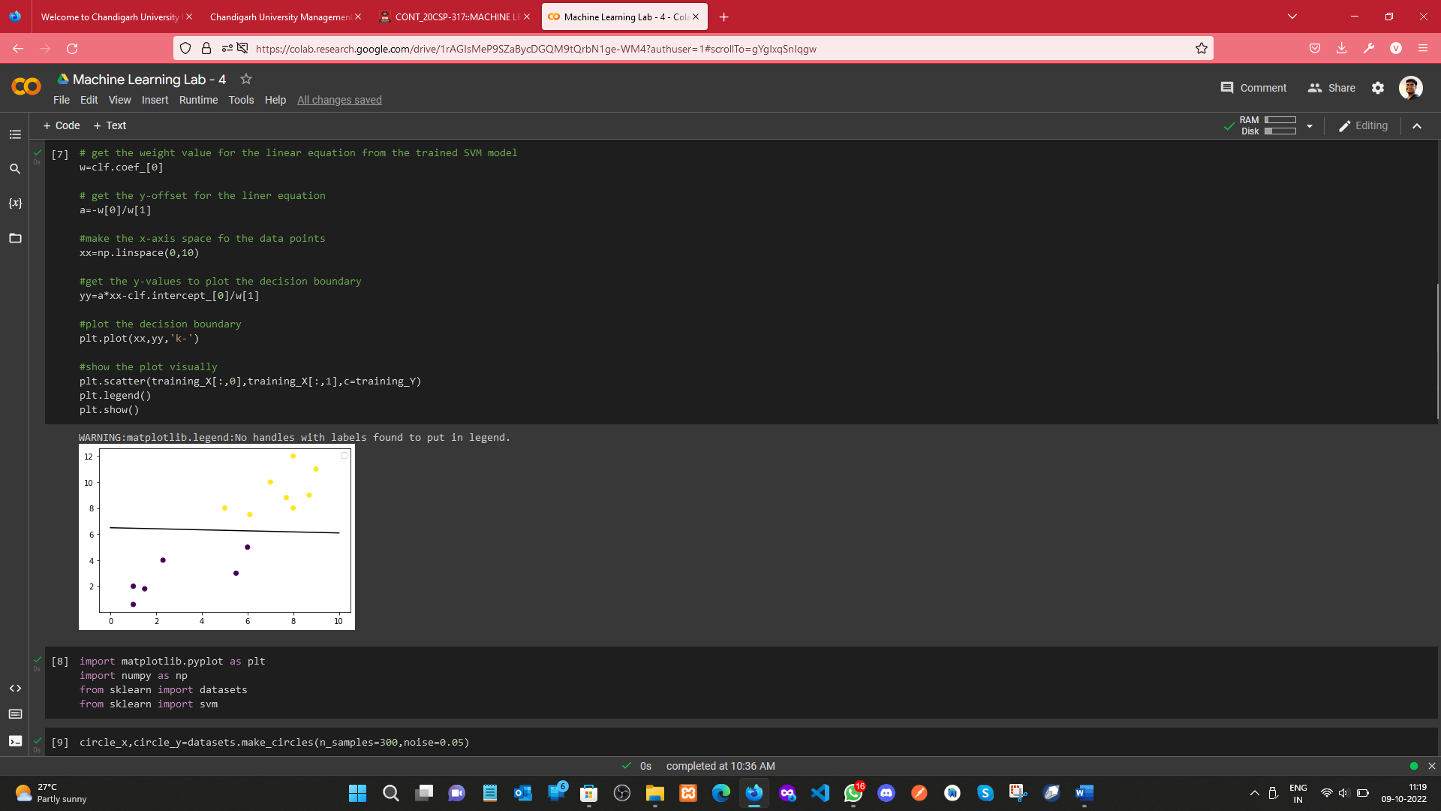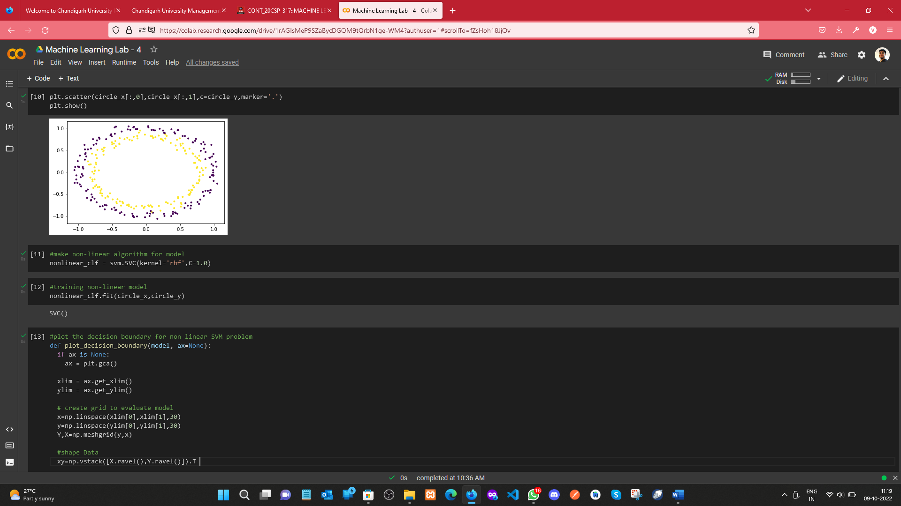

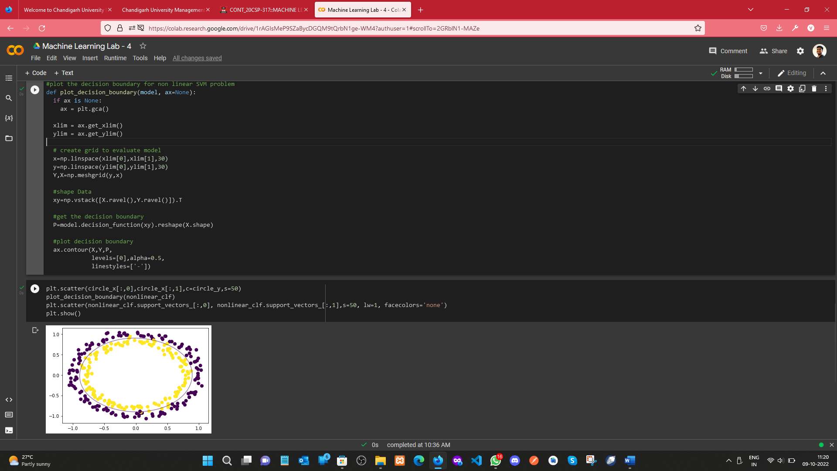

**Learning outcomes (What I have learnt):**

1. Understood the concept of SVM
2. Learnt how to find the Hyperplane and Decision boundary.
3. Plotting the Hyperplane and Decision Boundary

**Evaluation Grid (To be created as per the SOP and Assessment guidelines by the faculty):**

|  |  |  |  |
| --- | --- | --- | --- |
| Sr. No. | Parameters | Marks Obtained | Maximum Marks |
| 1. |  |  |  |
| 2. |  |  |  |
| 3. |  |  |  |
|  |  |  |  |